SSMS Task Revamp

-Aryan Gupta (2022B3PS0495P)

NEW APK: <https://drive.google.com/file/d/156rXBN5COZNOnpvHP5dAQA8EOANyUvJv/view?usp=sharing>

1. **UI**

Before:

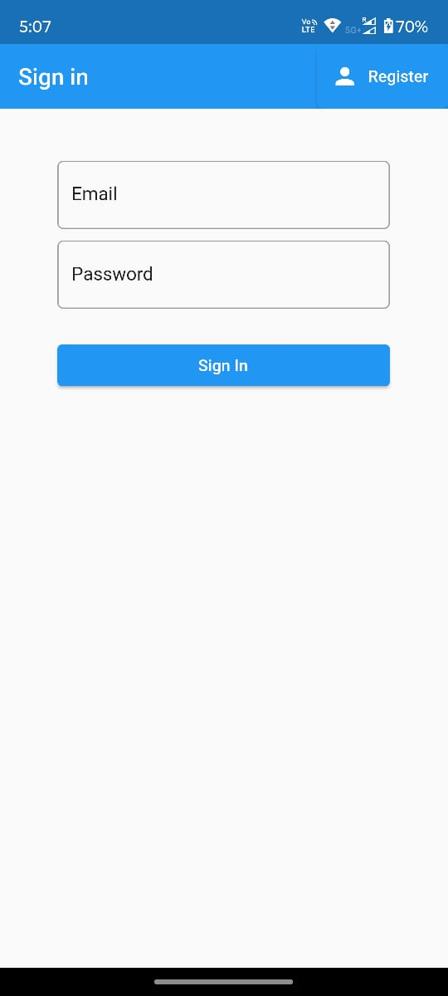

After:

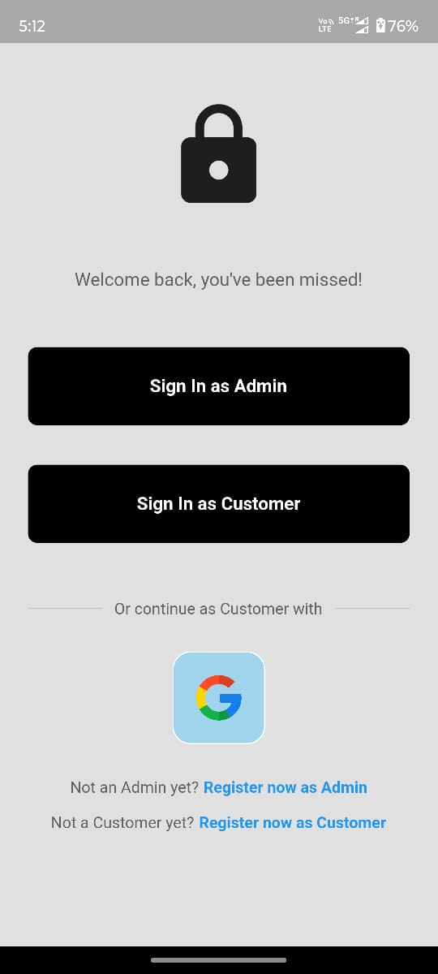

1. **IMPLEMENTED GOOGLE-SIGN IN**

Before:

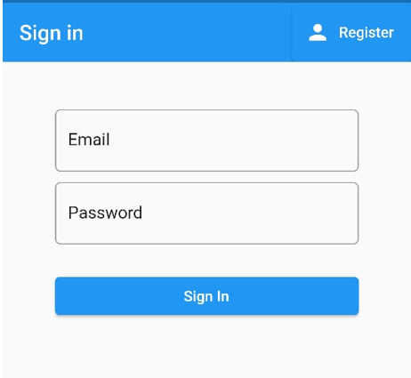

After:

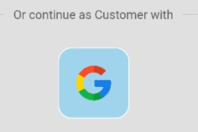

1. **DEFINED ROLES + SIGNIN/UP FOR ADMIN/USER**

Before:



After:

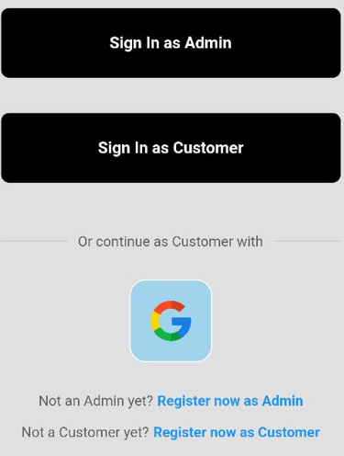

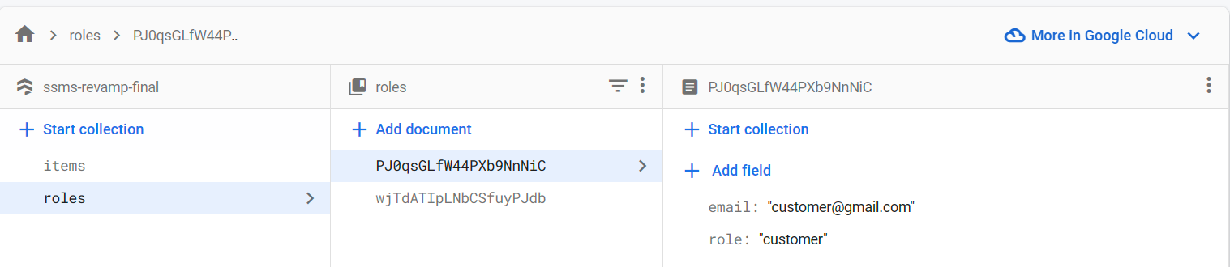

1. **IMPLEMENTED ROLE WISE PERMISSIONS**

Features for Admin:

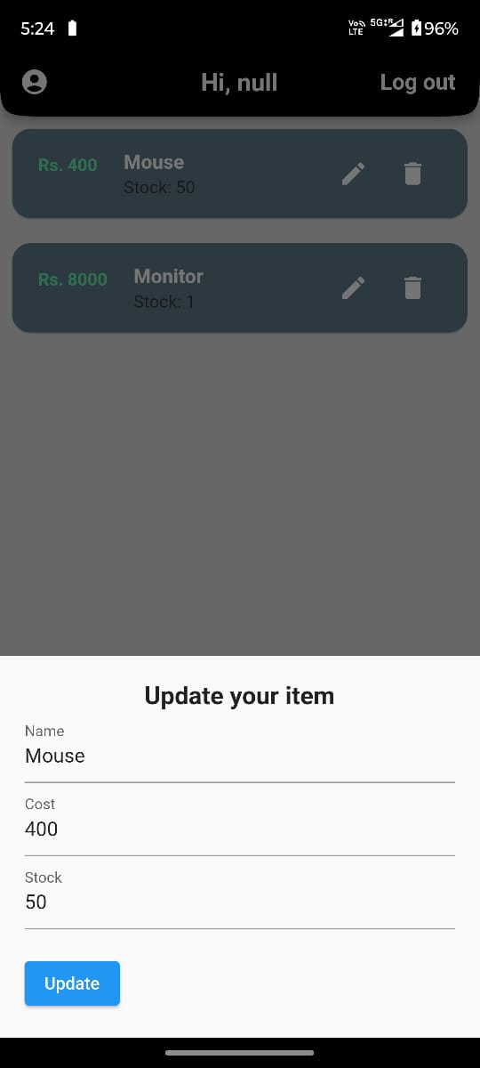

Features for Customer:

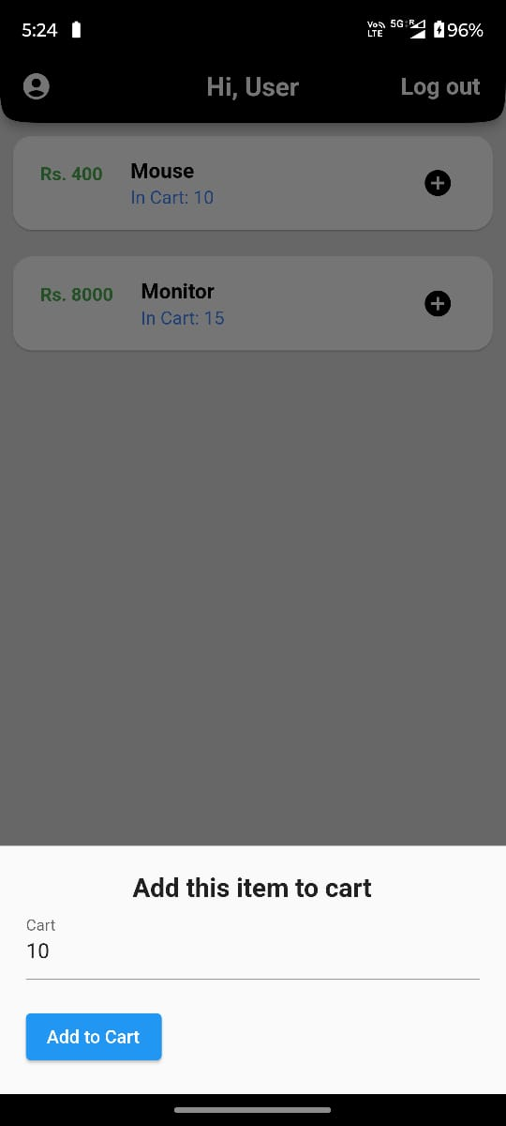

1. **IMPLEMENTED CART WITH REAL TIME UPDATES**

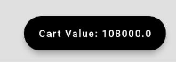

Firebase Code:

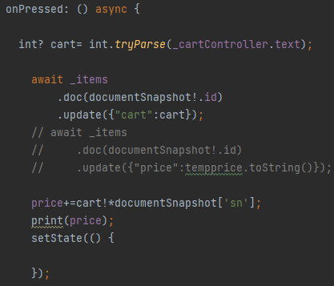

1. **LINKED NEW LOCAL DB – Hive for Username**

Relevant Screenshots:

